wireshark dump

invoke ProvideSubscriberLocation

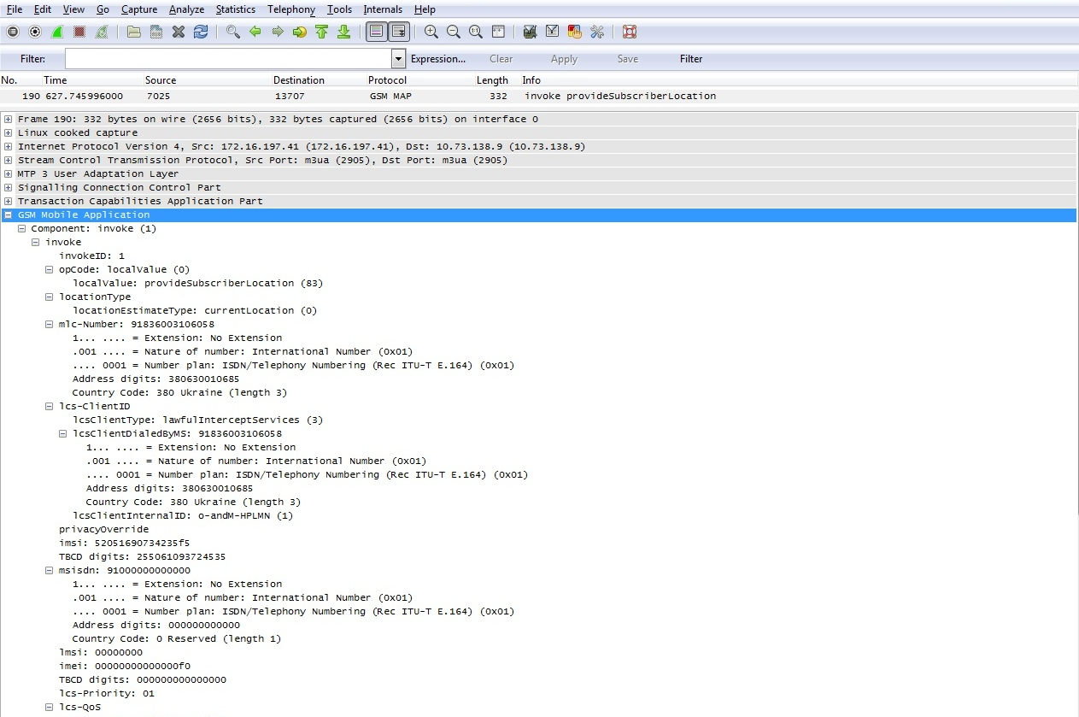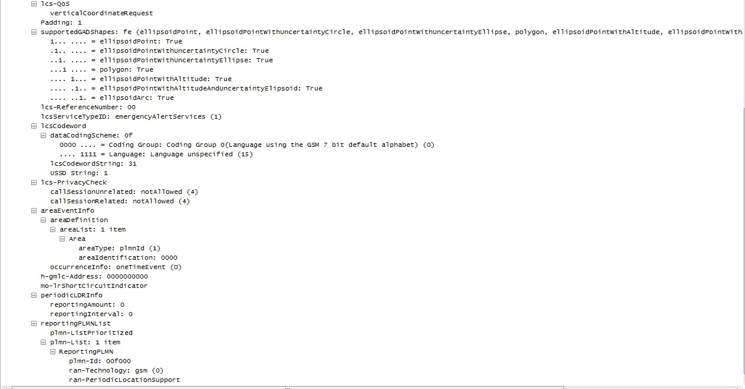

wireshark dump

returnResult ProvideSubscriberLocation

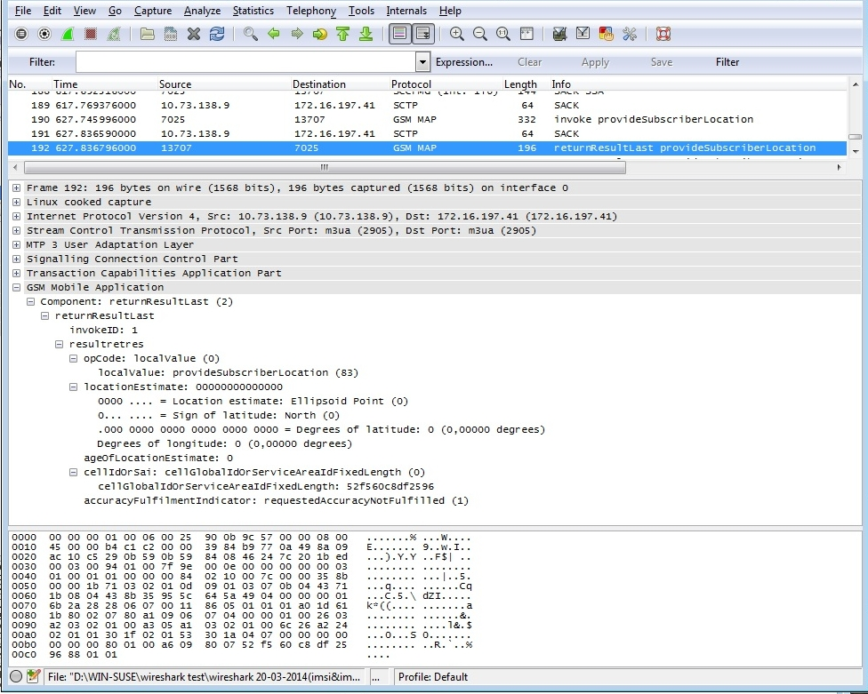

th